 | 10.1.9 Editors - Compositor Editor - Header - Add Menu - Creative
Table of content
Detailed table of content 1
Add menu - Creative 2
Kuwahara 2
Pixelate 2
Posterize 3

Detailed table of content

Detailed table of content
Detailed table of content 1
Add menu - Creative 2
Kuwahara 2
Inputs 2
Image 2
Size 2
Properties 2
Kuwahara Filter 2
Classic 2
High Precision 2
Anisotopic 2
Uniformity 2
Sharpness 2
Eccentricity 2
Outputs 2
Image 2
Pixelate 2
Inputs 3
Color 3
Size 3
Outputs 3
Color 3
Posterize 3
Inputs 3
Image 3
Steps 3
Outputs 3
Image 3

Add menu - Creative

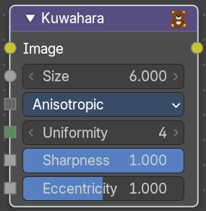
Kuwahara
Kuwahara is a filter that converts a realistic image into a stylized image.

Inputs

Image
Standard image input.

Size
The size of the kuwahara filter in pixels.

Properties


Kuwahara Filter
There are two Kuwahara variations available. Classic and Anisotropic.

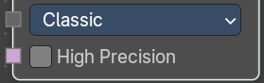
Classic

High Precision
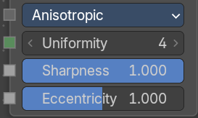
Use high precision. Slower but more accurate.

Anisotopic

Uniformity
Controls the uniformity of the direction of the filter.

Sharpness
Controls the sharpness of the filter. 0 is completely smooth, while 1 is completely sharp.

Eccentricity
Controls how directional the filter is.

Outputs

Image
Standard image output.

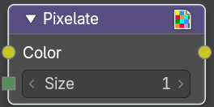
Pixelate
Add this node in front of a Scale node to get a pixelated (non-smoothed) image from the resultant upscaled image.

Inputs

Color
Standard image input.

Size
The number of pixels that corresponds to the same output pixel.

Outputs

Color
Image output.

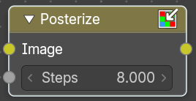
Posterize
The Posterize node reduces the number of colors in the image to a palette. The exact number of output colors is not to set. Just a number of steps to reduce the existing colors.

Inputs

Image
The image to reduce the colors at.

Steps
The number of steps to perform a color reduction.

Outputs

Image
Standard image output.

